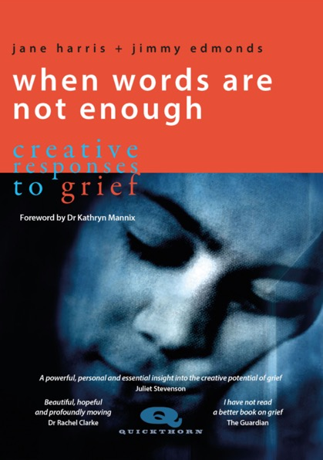
Title: When Words Are Not Enough
Subtitle: Creative Responses to Grief
Authors: Jane Harris and Jimmy Edmonds
Release date: September 2022
Publication: 5 October 2022
ISBN: 978-1-912480-57-9
Dimensions: 198 x 129mm
Extent: 128pp
Binding: paperback with flaps
Price: £19.99
Series: Quickthorn
Thema Code: VFJX
Subject: Grief; creativity; self-help; photography
Readership: The bereaved, their families and friends
Foreword: Dr Kathryn Mannix

‘I have not read a better book on grief.’ Annalisa Barbieri, The Guardian

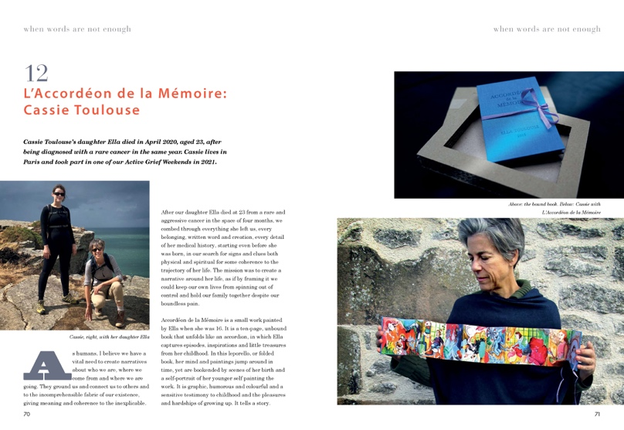
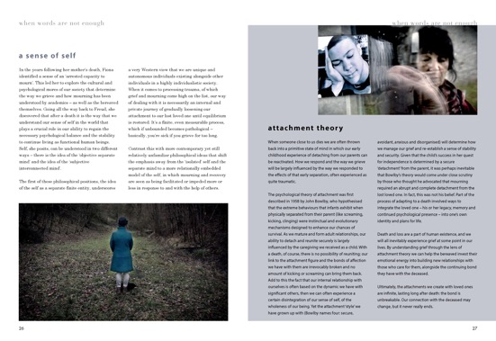
Everyone grieves for someone at some point in their lives. But how do we deal with the silence that often surrounds grief? How do we find ways to express painful feelings when words are not enough? In this deeply personal and beautiful reflection on grief Jane Harris and Jimmy Edmonds draw on their own experience of loss, and how the death of their son Josh has led to a creative response that is more than word bound.

In 2011 Jane Harris and Jimmy Edmonds’ son Joshua died in a road accident while travelling in Vietnam. In the years that followed they founded The Good Grief Project, a UK based charity to support other bereaved families and to promote their understanding of grief as creative and active process. This book follows their journey. It also tells the story of 13 other bereaved people who have also found a creative response to their grief.

The emphasis on 'continuing bonds' and their own way of maintaining a relationship with Josh, is both emotional and practical. Echoed in the other case studies they illustrate how creativity can shape a future where the deceased still play a part even while physically absent and how this is a normal and restorative aspect of the grieving process. Grief can also be a wonderful educator with new discoveries to be had.

Dotted throughout the book you will find boxes with reflections on current theories, and which explain the jargon you may hear used about grief. In the ‘Ten Things we have Learned’ the authors share the most useful things they found on their own bereavement journey. Eleven years on they have discovered how grief is almost by definition a creative process, one of making things anew that would not have existed had their son not died.

‘This is a book about sorrow, yet it is brimming with hope. This is a book about loss, but it overflows with love and generosity. The community of bereaved people is as diverse as humanity itself, and this book is a gathering of their wisdom, guided and curated by the creative talents and parental grief of Jane Harris and Jimmy Edmonds.’ Dr Kathryn Mannix, author of With the End in Mind and Listen

‘In the absence of any collective rituals or words with which to express their loss, this wonderful and very personal book offers those who find themselves in an agonising wilderness of grief, a kind of creative map to find a way out of the isolation.’ Juliet Stevenson, Actor

‘When Words are Not Enough shows us that searing loss isn’t necessarily the end, but a possible beginning. It’s an exploration with whatever means one has at one’s disposal – visual arts, the written word, even wild swimming – to mark, mourn, remember, salve and to create a tangible from a loss, some order from the arbitrary.’ Greg Wise, Actor

‘The word I keep coming back to with this book is beautiful, not a word I would usually associate with grief. But this book is rich in detail and compassion, it is authoritative and kind. Through their immense loss and pain Jane and Jimmy have done an extraordinary thing and redefined grief as love turned inside out. They make grief less scary. I have not read a better book on grief.’ Annalisa Barbieri, The Guardian

‘When Words are Not Enough offers that rarest of bereavement resources – a visual and verbal feast and a sustained look into the heart of grief that both acknowledges the raw anguish of tragic loss and invites the reader to share a fascinating and varied gathering of responses to it. I recommend it highly to all those who mourn, and all those who strive to accompany them through the experience.’
Prof Robert Neimeyer, Director, Portland Institute for Loss and Transition

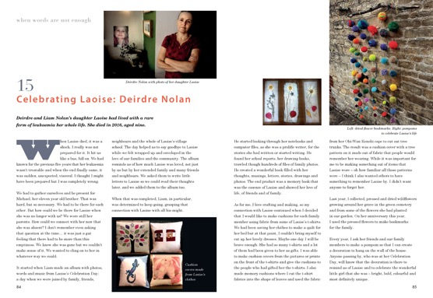
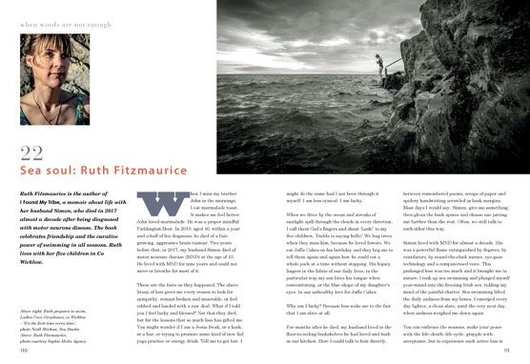

When Words Are Not Enough opens up new ways of thinking and talking about grief as a creative, generative ‘state of being’ which transforms who we are and how we see the world. The result is moving and important – and a beautiful testament to love.
Dr Lesel Dawson, Associate Professor in Literature and Culture, University of Bristol

Such an inspiring book - full of moving stories of people who have found active ways to respond to their grief, from photography through to (my favourite) cold-water swimming. Jane and Jimmy’s ten ‘lessons learned’ about the loss of their child wisely reject any idea of ‘moving on’ or ‘closure’. Indeed, this beautifully designed creation is itself an example of what the book is all about.
Prof Sir David Spiegelhalter, Statistician, University of Cambridge

The Authors
Jane Harris is a psychotherapist and bereavement specialist with over 30 years of experience in the NHS and private practice. She is also a grief educator and public speaker. Jimmy Edmonds is a photographer and documentary film editor with over 100 TV credits including the BAFTA winning Chosen for Channel 4 and his own personal film Breaking the Silence for BBC1. Together they make films including the award winning A Love That Never Dies and have founded The Good Grief Project with the mission of supporting families grieving after the untimely death of a loved one, particularly the death of a child. They like to promote a proactive approach to grief which they encourage on their regular Active Grief Weekend retreats.

Quickthorn Ltd is a new publishing venture based near Stroud creating books about resilience and sustainability. Mindful of our impact on the environment we use local suppliers and materials and print our books in the UK.

